**Exercise 1: Configuring a Basic Spring Application**

**This exercise can be implemented just by the following steps:-**

**Step 1.1.** Create a New Maven Project->  
 If you're using **IDEA (IntelliJ)** or **Eclipse**, you can create the project using the UI. Alternatively, you can use the **command line**:

mvn archetype:generate -DgroupId=com.library -DartifactId=LibraryManagement -DarchetypeArtifactId=maven-archetype-quickstart -DinteractiveMode=false

This creates a basic Maven project structure.

**1.2. Add Spring Core Dependencies in pom.xml:**

Update the pom.xml:

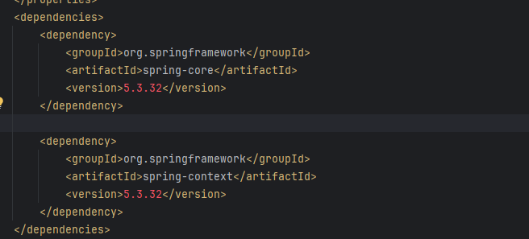

Then reload the maven using this button 

**Step 2: Configure the Application Context**

**2.1 Create XML file:** Create a new file applicationContext.xml under src/main/resources.

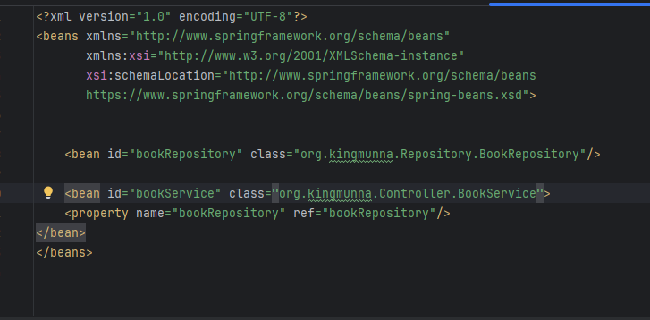

### ****Step 3: Define Service and Repository Classes****

**3.1 BookRepository.java**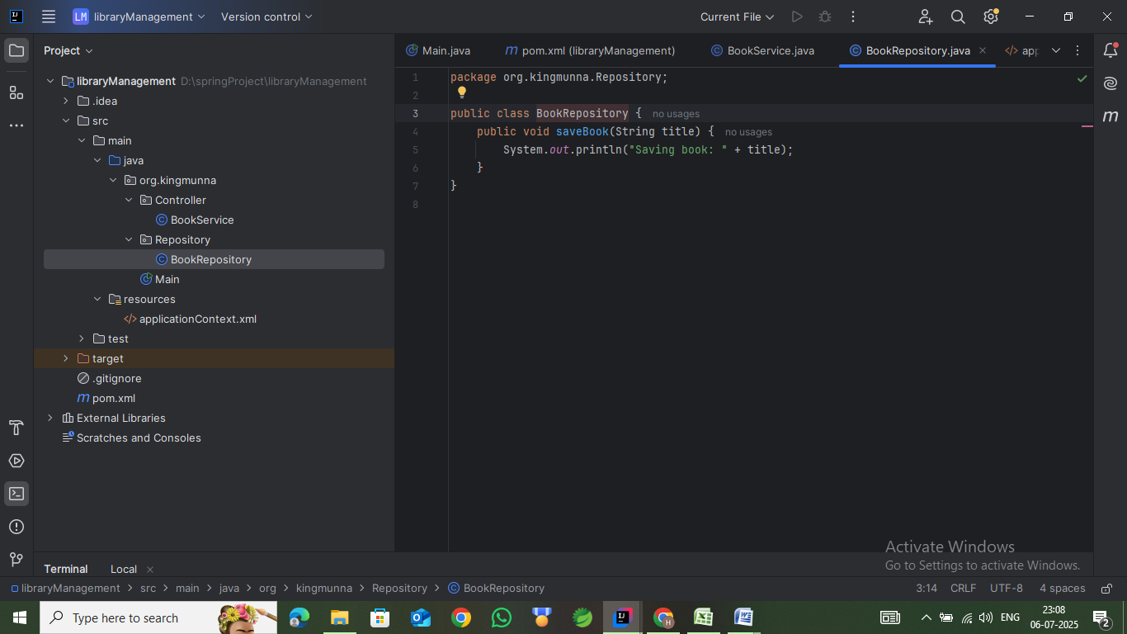

**3.2 BookService.java**

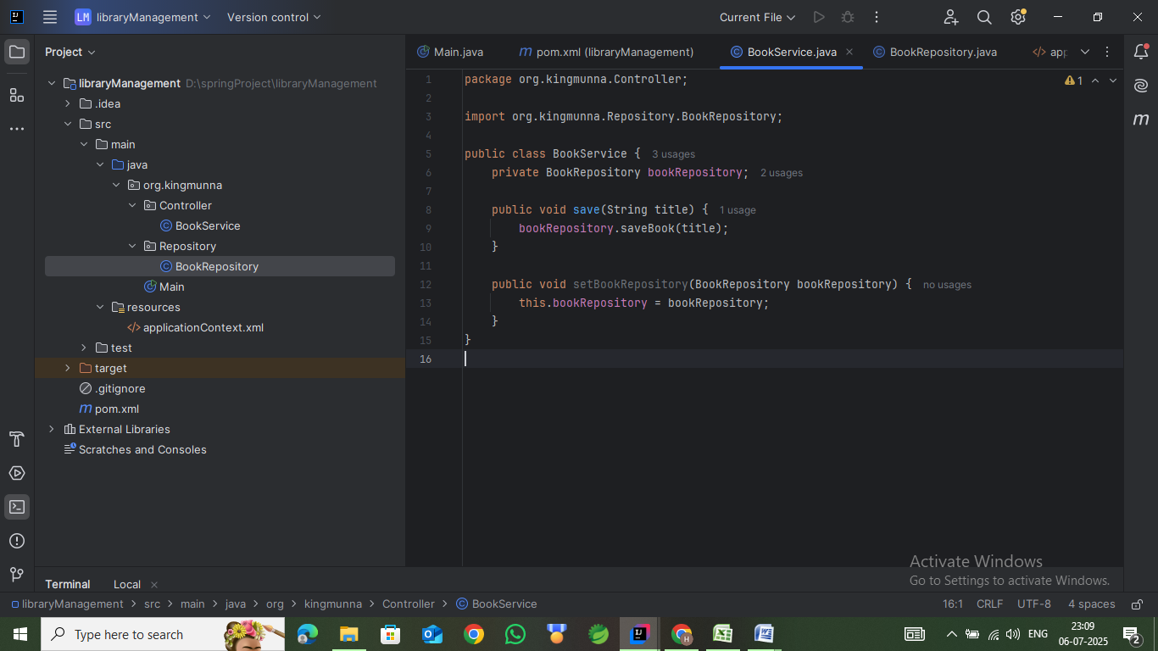

**Step 4: Run the Application**

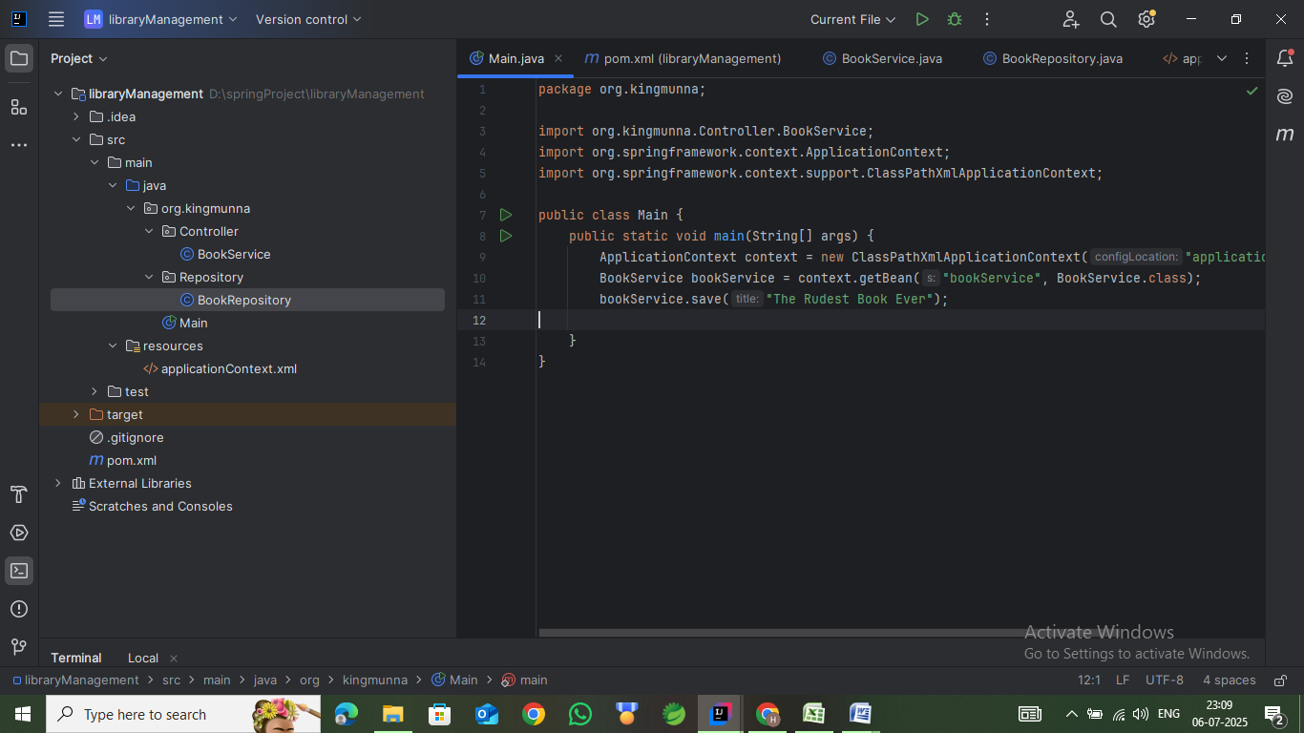

**Output :-**

